All your accounts are created automatically. No need to create manually.
Locate your login and temporary passwords in the letter with the subject: “Login credentials for NU systems & services” sent to your personal email. Check the Spam folder if unsuccessful.
You will not receive a letter if you have previously studied, worked, or work at the University.
In this case, use your old credentials.
If the passwords are lost, then restore them according to the file linked to FAQ.

Since the information services and resources of the University use 2 separate passwords, change them separately and sequentially:
- for corporate mail;
- for other information systems and corporate PCs.

Note:
1) the password should consist of no less than 8 symbols;
2) as a part of the password upper and lower register letters shall be used, taking into account the current keyboard layout (EN-RU-KZ), and figures and special symbols ( " ~ ! @ # $ % ^ & * ( ) - + _ = \ | / ?,) .

- Change the temporary password of the corporate email of the University

The University's corporate email uses Google's Gmail service. After the first login, change the temporary password sent to your personal email to a permanent one. The new password should be complex enough to minimize the risk of its leak.
  - Open the address in browser:
https://mail.google.com

1.2. In the field “Email or phone ” enter your corporate email address in the format yourname.yourlastname@nu.edu.kz
Example:
Name: Bauyrzhan
Lastname: Turezhanov
E-mail: bauyrzhan.turezhanov@nu.edu.kz
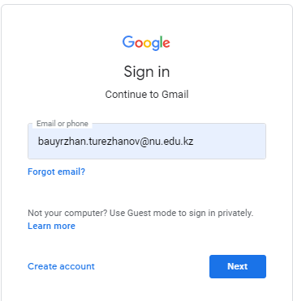

1.3. Enter the temporary password that you received on your personal email

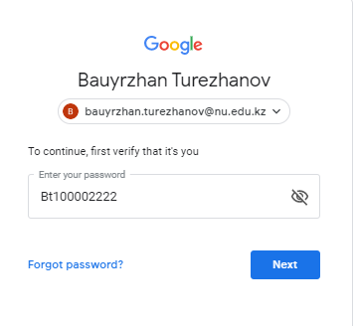

1.4. Set a new password.
To do this, enter the new password twice in the proposed fields and click the "Change password" button.
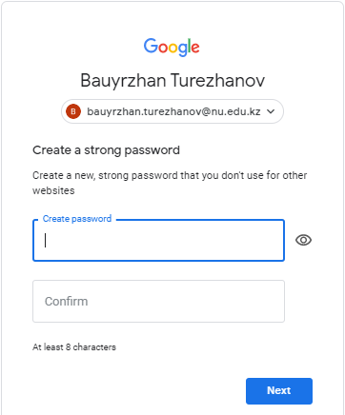

2. Change the temporary password of information systems and corporate PCs

Information systems and corporate PCs of the University use the authorization of the Microsoft Active Directory service. Changing the Active Directory password, it is changed in all information systems and corporate PCs except corporate email. The Active Directory password is changed and recovered using the Password Recovery Service and must be complex enough to minimize the risk of its leak.

2.1. Open in browser the address of Password Recovery Service https://prs.nu.edu.kz and click on “Change password”.
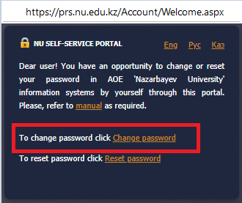

2.2 In the "Login" field enter in the format yourname.yourlastname
Example
Name: Bauyrzhan
Lastname: Turezhanov
Login: bauyrzhan.turezhanov
2.3 In the “Password” field enter the temporary password of corporate email that was sent to your personal email by a message with the subject “Login credentials for NU systems & services”.
2.4. In the third field enter the numbers from the picture with a blue background and click the “Log in” button.

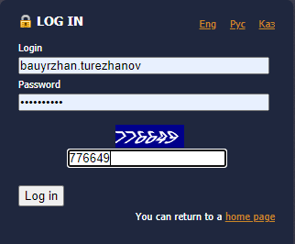

2.5 In the “Old password” field re-enter the temporary password of corporate email that was sent to your personal email with a message with the subject “Login credentials for NU systems & services”.
2.6 Next fields enter the new password twice in the “New password”, “Confirm password” and click the “Save” button.

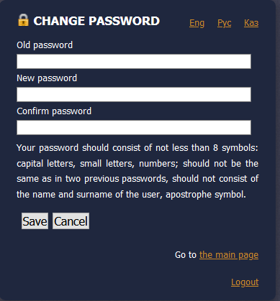

IMPORTANT! The following information systems uses a login in the format yourname.yourlastname and password of Active Directory:
https://moodle.nu.edu.kz
https://registrar.nu.edu.kz
https://library.nu.edu.kz
https://my.nu.edu.kz

